Supplementary material

1 Detection program
the field test is shown in Fig. S1
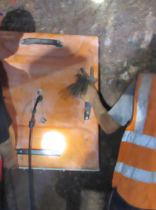
Fig. S1 Geological radar field test

2 Analysis of field test monitoring results
The collected data was then analyzed using specialized software. The results of the geo-radar tests for the 1# cavern is presented in Fig S2-4.

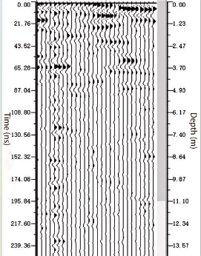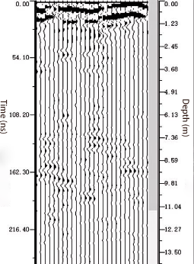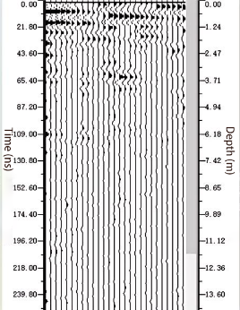
L₁ line measurement L₂ line measurement L₃ line measurement
Fig. S2 Geological radar waveform accumulation map of cavern #1 after cavern #1 blasting
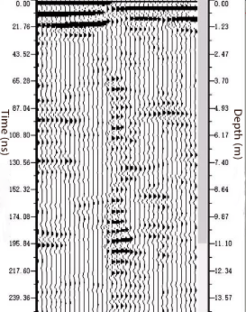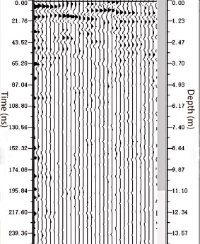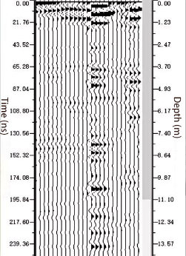
L₁ line measurement L₂ line measurement L₃ line measurement
Fig. S3 Geological radar waveform accumulation map of cavern #1 after cavern #2 blasting

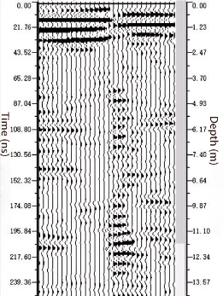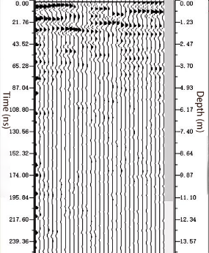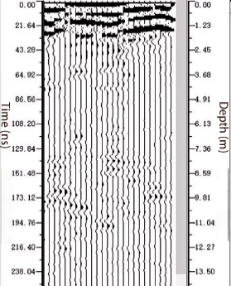
L₁ line measurement L₂ line measurement L₃ line measurement
Fig. S4 Geological radar waveform accumulation map of cavern #1 after cavern #3 blasting
From the L1 line (left side wall of the cavern) in Fig. 6, it is evident that the radar reflected radar-reflected wave at 0 ~ 1.32 m transitioned from high speed to low speed, and the amplitude decayed rapidly, indicating more severe damage to the surrounding rock within this depth range. The damage to the perimeter rock in this cavern was determined to be between 0 ~1.32 m. Similarly, it was found that the damage to the perimeter rock on the L2 line (right side wall of the cavern) occurred between 0 ~ 1.34 m, while on the L3 line (roof), it ranged from 0 ~ 1.46 m.

3 Blasting Test Scheme
Given the heavy safety tasks and urgent construction period facing the current situation, blasting in adjacent caverns poses a potential risk to the safety and stability of excavated underground caverns. This paper analyzes the cumulative damage effect of surrounding rock under multiple blasting loads in adjacent caverns as well as examines the influence of cavern spacing on surrounding rock damage and its correlation with peak particle velocity. The results from this blasting test can provide valuable insights for ensuring future construction safety within porous tunnel or cavern groups. The layout of the holes remains unchanged (see Fig. S5 for field drilling).
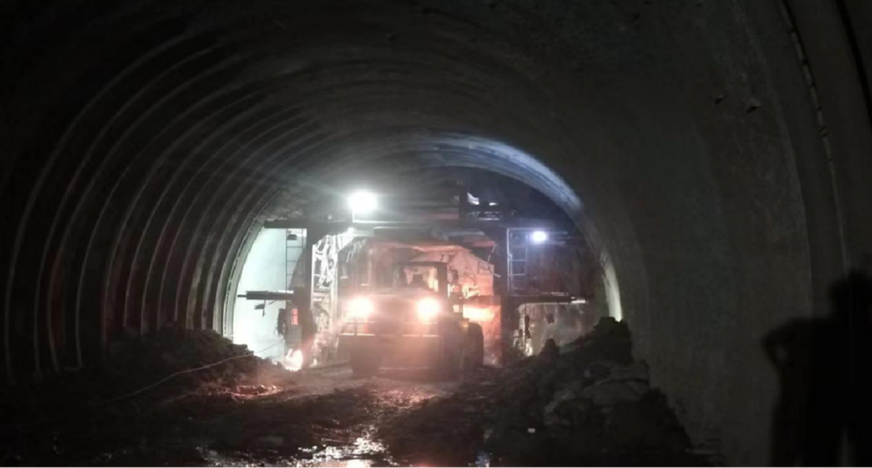
Fig. S5 Diagram of site drilling and blasting excavation

